**Organ Donation System**

T.E. mini-project report submitted in partial

fulfilment of the requirements of the degree

of

**Bachelor of Engineering (B.E)**

in

**COMPUTER ENGINEERING**

by

**Vrushal Patil [EU1212085]**

**Priyank Raut [EU1212120]**

**Chirag Rawat [EU1212029]**

**Ranu Singh [EU1212106]**

Under the guidance of

**Dr. Nilesh T. Deotale**



**Department of Computer Engineering**

**St. John College of Engineering and Management, Palghar**

**University of Mumbai**

2023-2024

**CERTIFICATE**

This is to certify that the T.E. mini-project entitled **“Organ Donation System”** is a bonafide work of “**Vrushal Patil” [EU1212085**], “**Priyank Raut” [EU1212120],** “**Chirag** **Rawat” [EU1212029],** “**Ranu Singh” [EU1212106]**  submitted to University of Mumbai in partial fulfilment of the requirement for the award of the degree of **“Bachelor of Engineering”** in **“Computer Engineering”** during the academic year 2023-2024.

**Dr. Nilesh T. Deotale Dr. G.V. Mulgund** Head of Department and Project Guide Principal

**T.E. Mini-Project 2A Report Approval**

This mini-project entitled **Organ Donation System** by **Vrushal Patil, Priyank Raut, Chirag Rawat, Ranu Singh** is approved for the degree of **Bachelor of Engineering** in **Computer Engineering** from **University of Mumbai.**

**Examiners**

**1.**

**2.**

**Date:**

**Place:**

**Declaration**

We declare that this written submission represents our ideas in our own words and where others’ ideas or words have been included, we have adequately cited and referenced the original sources. We also declare that we have adhered to all principles of academic honesty and integrity and have not misrepresented or fabricated or falsified any idea/data/fact/source in our submission. We understand that any violation of the above will be cause for disciplinary action by the Institute and can also evoke penal action from the sources which have thus not been properly cited or from whom proper permission has not been taken when needed.

Vrushal Patil [EU1212085]

Priyank Raut [EU1212120]

Chirag Rawat [EU1212029]

Ranu Singh [EU1212106]

**ABSTRACT**

Organ donation is the donation of biological tissue or an organ of the human body, from a living or dead person to a living recipient in need of a transplant. Transplantable organs and tissues are removed in a surgical procedure following a determination, based on the donor’s medical and social history, of which are suitable for transplantation.

To implement this project, we have used React for the front end and Node.js with MongoDB for the back end. Node.js provides a robust environment for server-side scripting, while MongoDB offers flexibility in managing our database with its NoSQL capabilities. React, known for its component-based architecture, enhances the user interface with efficient rendering and state management. The Organ Donation System aims to streamline the process of finding organ donors, providing hospitals with a cost-effective and time-saving solution tailored to their needs.

**Table of Contents**

|  |  |  |
| --- | --- | --- |
| **Chapter** | **Content** | **Page no**. |
|  | **Abstract** | i |
|  | **List of Figures** | iii |
|  | **List of Tables** | iii |
| **Chapter 1** | **Introduction** | 1 |
|  | 1.1 Motivation | 1 |
|  | 1.2 Problem Statement | 2 |
|  | 1.3 Objectives | 2 |
|  | 1.4 Scope | 2 |
| **Chapter 2** | **Review of Literature** | 3 |
|  | 2.1 Comparative Study | 6 |
| **Chapter 3** | **Requirement Analysis** | 7 |
|  | 3.1 Hardware and Software requirements | 7 |
| **Chapter 4** | **Report and Present Investigation** | 8 |
|  | 4.1 Proposed System | 8 |
|  | 4.1.1 Block Diagram of Proposed System | 8 |
|  | 4.2 Implementation | 8 |
|  | 4.2.1 Flowchart | 9 |
|  | 4.2.2 ER-Diagram | 10 |
|  | 4.2.4 Screenshots of Output with Description | 19 |
| **Chapter 5** | **Results and Discussion** | 23 |
| **Chapter 6** | **Conclusion** | 24 |
|  | **Reference** | 25 |
|  | **Acknowledgement** | 26 |

**List of Figures**

|  |  |  |
| --- | --- | --- |
| **Figure No.** | **Figure Name** | **Page No.** |
| 4.1.1 | Block Diagram of Proposed System | 8 |
| 4.2.2 | Flowchart | 9 |
| 4.2.3 | ER-Diagram |  |
| Fig 1 | Main Login Page | 19 |
| Fig 2 | Signup Page | 19 |
| Fig 3 | Donor Login | 20 |
| Fig 4 | Recipient Login | 20 |
| Fig 5 | Hospital Login | 21 |
| Fig 6 | Eligibility Test | 21 |
| Fig 7 | Donor Registration | 22 |

**Chapter 1**

**Introduction**

Transplants are one of the most miraculous achievements of modern medicine whereas transplantation is one of the most challenging and complex areas of modern medicine. Organ transplantation is the process of surgically transferring a donated organ into a patient with end stage organ failure. It has been found that the number of donors is far less than the number of organ recipients.

The primary reason behind this is the lack of communication between donors and recipients. Due to the absence of a connecting platform, the recipients are unable to reach out to the donors. Data storage of the patients and donors is more prone to hacking than a distributed system. As per the current system the entire data is stored at a single point, thus shifting to a distributed system will introduce more security

**1.1Motivation**

Earlier there was a problem related to organ donation also it was time consuming for both donor and receiver, this results in wastage of organs. There are many deaths due to unavailability of organs or donors at that time.

Online organ system provides a better way to overcome these problems and also helps to communicate between donor and receiver.

**1.2 Problem Statement**

Hospitals take time to find the Donor as per requirement. There has been a major increase in the number of patients on transplant waiting lists. There is a disparity between the supply and demand of donated organs, which leads to a loss of many lives.

**1.3 Objectives**

The system focuses on providing better services to the people by Connecting the Hospitals as well as the Donor and the Receiver together. It helps the hospitals to find the Donor and Receiver. Through this application all of them are connected in one platform. It will Help the Receiver to find the donor as per their requirement and a hospital where the organ transplantation is done. It will take record of the Donor, Receiver and the Hospitals. Through this application the Hospital will be able to take some test of Donor and take a record as a detailed form.

* 1. **Scope**
* This will solve the major problem where the patients are waiting for the organ transplant. It will decrease the number of patients listed.
* It will help Receiver to find the Donor.
* It will take a proper record of the Donor, Receiver & Hospital and check some
* test regarding Donor.

**Chapter 2**

**Review Of Literature**

**PAPER 1:** Block Chain-based Management for organ Donation and Transplantation, 2022.

Journal: IJCCM

Author Name: Diana Haswashin, Raja Jayaraman, Khaled Salah, Ibrar Yaqoob.

Today’s organ donation and transplantation systems pose different requirements and challenges in terms of registration, donor-recipient matching, organ removal, organ delivery, and transplantation with legal, clinical, ethical, and technical constraints. Therefore, an end-to-end organ donation and transplantation system is required to guarantee a fair and efficient process to enhance patient experience and trust. In this paper, we propose a private Ethereum blockchain-based solution to enable organ donation and transplantation management in a manner that is fully decentralized, secure, traceable, auditable, private, and trustworthy. We develop smart contracts and present six algorithms along with their implementation, testing, and validation details. We evaluate the performance of the proposed solution by performing privacy, security, and confidentiality analyses as well as comparing our solution with the existing solutions. We make the smart contract code publicly available on GitHub

In this paper, we have proposed a private Ethereum blockchain-based solution that manages organ donation and transplantation in a decentralized, accountable, auditable, traceable, secure, and trustworthy manner. We developed smart contracts that ensure the data provenance by recording events automatically. We present six algorithms with their implementation, testing, and validation details.

**PAPER 2:** Decentralised and Distributed System for Organ/tissue Donation and Transplantation 2019.

Journal: CICT

Authors: Pratyush Rajan, Shubhankar, Ssrivastava Vidit Gupta, Tapaswi, Neetesh Kumar.

In the digital automatizing process, security and privacy are the most important and highly demanding aspects. Blockchain offers many features that can be used in almost every sphere of life. Features like decentralization, transparency, privacy makes it an extremely useful technology. Therefore, by making use of all these features, several problems in the healthcare sector can be solved like removing complex networks of third parties and lack of traceability of transactions. This paper presents a decentralized, secure and transparent organ and tissue transplant web application, which not only nullifies the role of any third party involved in the organ transplantation, but also is a cost-effective solution that saves the patients from high cost of transplantation. The details and Electronic Medical Record (EMR) are hashed using the IPFS (a distributed file server), which reduces the cost of upload to a great extent as shown in the results section of this paper.

In this application, a donor registers itself and gets approved by the hospital module. Based on the request, the hospital module recipient matches the with an appropriate donor.

**PAPER 3:** An Intelligent organ Distributed Using Internet of things Driven System, 2017.

Journal: ICCES

Authors: Ms. Benita Jose, Chalissery, Ms. Asha V.

Timely organ transplantation is one of the most challenging and complex areas of modern medicine. Wireless sensor-based systems, microcontrollers, healthcare-specific gateways and cloud-based servers can contribute a vital role in making a timely transplantation. This can help to increase the utilization of available healthy organs from the pool that are presently going unused. Internet of Things driven systems can help in well-timed transplantation particularly for organs like kidney and liver which have only a few hours of preservation time. This paper proposes an IoT based organ procurement and distribution system which can bring remarkable improvement in timely procurement, accurate serotyping, and resolving ethical, legal and clinical issues. It also helps to attain a healthy patient graft survival.

The proposed framework is capable of providing its customizable list of recipients based on multiple possible optimization factors such as HLA matching, waiting time, medical status and distance. The dynamic management scheme operates in real time and emulates the judgment made by the transplant team.

**PAPER 4:** Blood and Organ Donation management System, 2020.

Journal: IEEE

Authors: P.L Wijayathilaka, P.H. Phala, Gamage, K.H.B Desilva.

many discrepancies in current approaches. These have created the criteria for malpractices such as organ trafficking and black market selling. This research presents a solution with a secured smart blood and organ donation web developed system, allowing both patients and healthcare providers to access information about the blood and organ processing records. The database would be managed using the Blockchain technology which could be only accessed by authorized users. Finally, tracking all registered donors, the proposed system generates a smart identity developed by Ethereum Smart Contract (ESC). System predicts blood demand for the future ten years using the Linear Regression Model with 0.998 of high R-squared accuracy value. This reduces shortages and wastage of blood. Also, using the global positioning system and K-Nearest Neighbors Machine Learning algorithm, the system finds the best matches among donors and seekers according to the nearest location. Further, the system will automatically send questionnaires for registered users to identify and evaluate their awareness and issues about organ donation. Overall, this study aims for a secured and transparent web application. Thus, it facilitates an innovative and productive blood donation and organ transplantation process in the Sri Lankan healthcare sector.

An exclusive feature of this ‘Lifeshare’ application was it can be shared within any blood bank connected through the general hospitals as well as for private hospitals by including their relevant databases.

**PAPER 5**: Tracking of Blood Donor AND Organ Donor Application, 2019.

Journal: IJRTE

Authors: Bhagya Lakshmi, D.N. Usha. S.

This paper gives a detailed report on the application available for tracking blood donors and organ donors which helps to assist between blood donors and needy people. It facilitates the search process for necessitate people and it will be effortless before. With development in healthcare services Organ transplantation is increasing in demand so blood donation has become important. It is important all this information to be available as when required by hospitals and patients. There is a need of uniform tool to maintain much medical related

information like organ transplantation requirements of organs in different hospitals. Information about blood donors across the globe. The recent trends in technology have helped in the healthcare field to facilitate the blood and organ donors for the necessitous people & provides complete health solutions that supplies blood for the required patients in time, it is safest & through trustable means. For blood samples that are uncommon or the software can search in the MIS & displays the information to the user.

Blood is the primary necessity of life. There are different scenarios for searching blood Donors. This proposed system is one step ahead from other blood donation systems.

**2.1 Comparative Study**

Table 2.1 Tabular Comparison of the referred Research Papers

|  |  |  |  |  |
| --- | --- | --- | --- | --- |
| **NO.** | **PAPER NAME** | **AUTHOR NAME** | **CONCLUSION** | **RESEARCH GAP** |
| 1. | Block chain-Based Management for organ donation and transplantation  IJCCM (2022) | Diana Hawashin,  Raja jayaraman,  Khaled Salah, Ibrar Yaqoob, Samer  ellahham | Analyzed security  of the proposed  solution against  common attacks  and vulnerabilities | In this paper they  have suggested the  process of Allograft  &  Allotransplantation  which takes lot of  time. Resulting the  damage of organ or  organ may get  useless. |
| 2. | Decentralised and Distributed System for Organ/tissue  Donation and  Transplantation  CICT (2019) | Pratyush Ranjan,  Shubhankar  Srivastava, Vidit  Gupta, Shashikala Tapaswi, Neetesh Kumar | Donor registers  itself and gets  approved by the  registered  hospital module. | This paper does not provide the facility for the authenticate  registration.  Therefore anybody  can put them  request so it  increases the fake entries |
| 3 | An Intelligent  organ Distribution Using internet of things-Driven  System  ICCES (2017) | Ms. Benita Jose  Chalissery, Ms.  Asha V | Blood recipient  can contact blood  donor directly  using this system.  This website can  also be used by  organ donor and  seeker was  person can search  for blood  donor or organ  Donor | There should be  improvements like  better inventory  management, and  emphasizes the  importance of  efficiently  connecting donors  with those in need. |

**Chapter 3**

**Requirement Analysis**

**3.1 Requirements for Organ Donation System:**

**3.1.1 Level 0 DFD**

**Organ Donation System**

###### Future Use

**Admin**

###### Donor

###### Hospital

###### Call Detail

**Data Base**

**Level 1 DFD**

3.1.2

**Login Database**

###### Admin

**Value Abilities Table**

**Level 1 DFD: For Users Module**

###### Register

**Value Abilities Table**

**3.1.3**

**Level 2 DFD**

###### Administrator

**Appointment Details**

Blood Details

Donor Report

Operator Report

Call Center Report

**Use Case Diagram**

**3.1.4 Use Case Diagram for Donor Module**

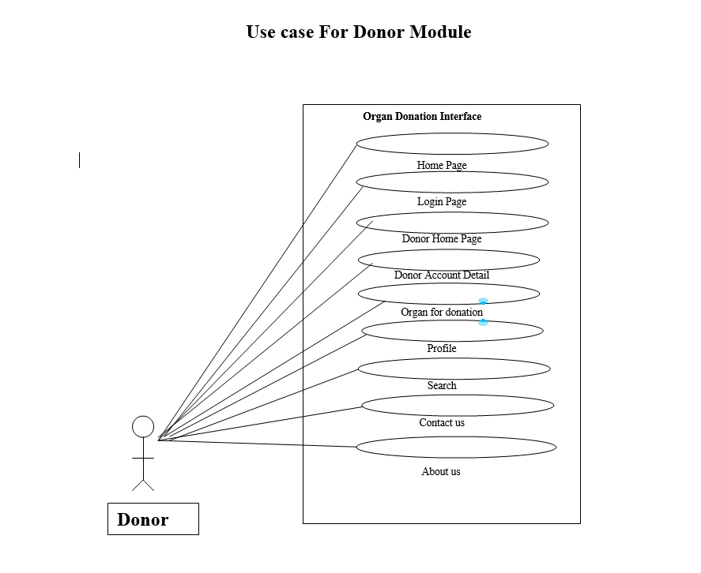

**3.1.5 Use case Diagram for receiver Module**

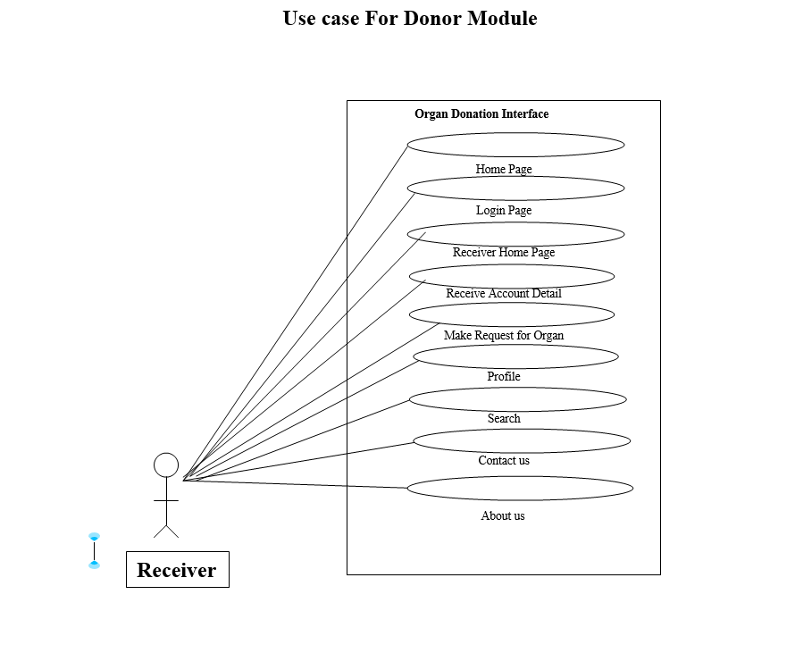

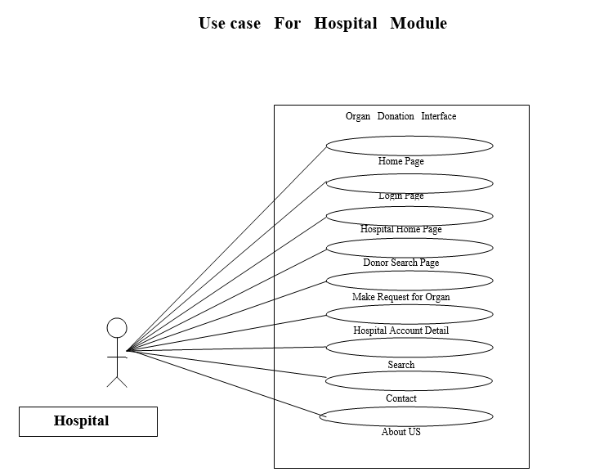

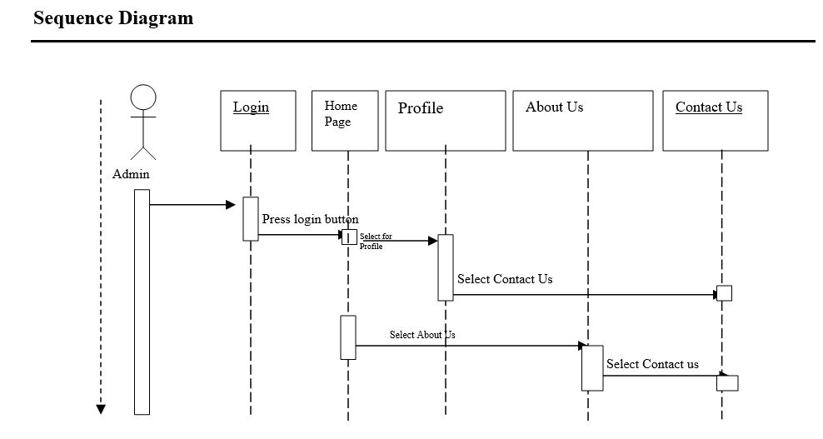**3.1.7 Sequence Diagrams**

**Chapter 4**

**Report on Present Investigation**

**4.1 Proposed System**

In Ours Application we had made Three Login Page and one as Main Login page which will redirect for future logins. We had made Administrator Login in which the registrations hospitals are login, and second one is User Login which is for the recipient/patients and last Login page for the Donor the people who want to donate their organs.

The Three Logins are as follow: -

a) Administration Login

b) Users Login

c) Donor Login

a) Administration Login: -

This Login page for the hospital where the Hospitals can Register as an administrator. Which the take a test or donor for checking the donor eligibility test, and which can also see the records of donor/recipients in further pages.

b) Users Login: -

This login page is of the Recipient, which can register itself and search for the

donor/organs.

c) Donor Login: -

This login page is of the Donor who can donate his organ with some criteria and test which donor wants to give to the hospital.

**4.1.1 Block Diagram of Proposed System**

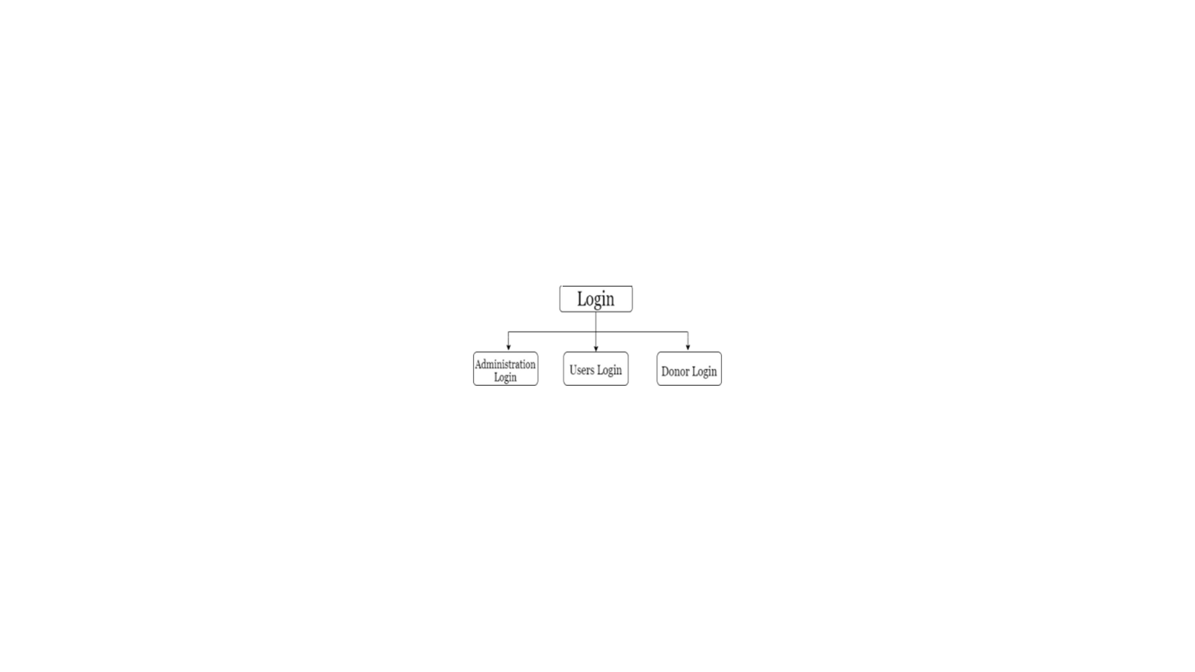

Fig. 4.1.1 Block Diagram of Proposed System

**4.2 Implementation:**

After their Login the Recipients will fill details of it and the ID as a Documents, and the Hospital will be able to see the Donor details as well as the Recipients details that recipients register for which organ. And the Donor will Give their eligibility test to check that he/she is capable of organ Donation or not.

**4.2.2 ER-Diagram**

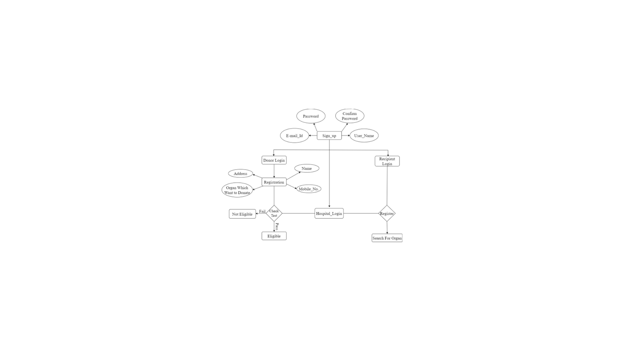

**4.4 Screenshots of the outputs**

**4.4.1 Login Page**

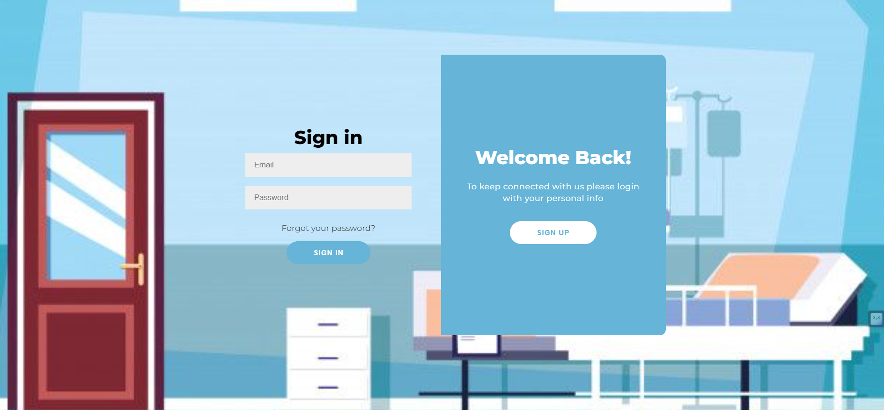

**4.4.2 Signing Page**

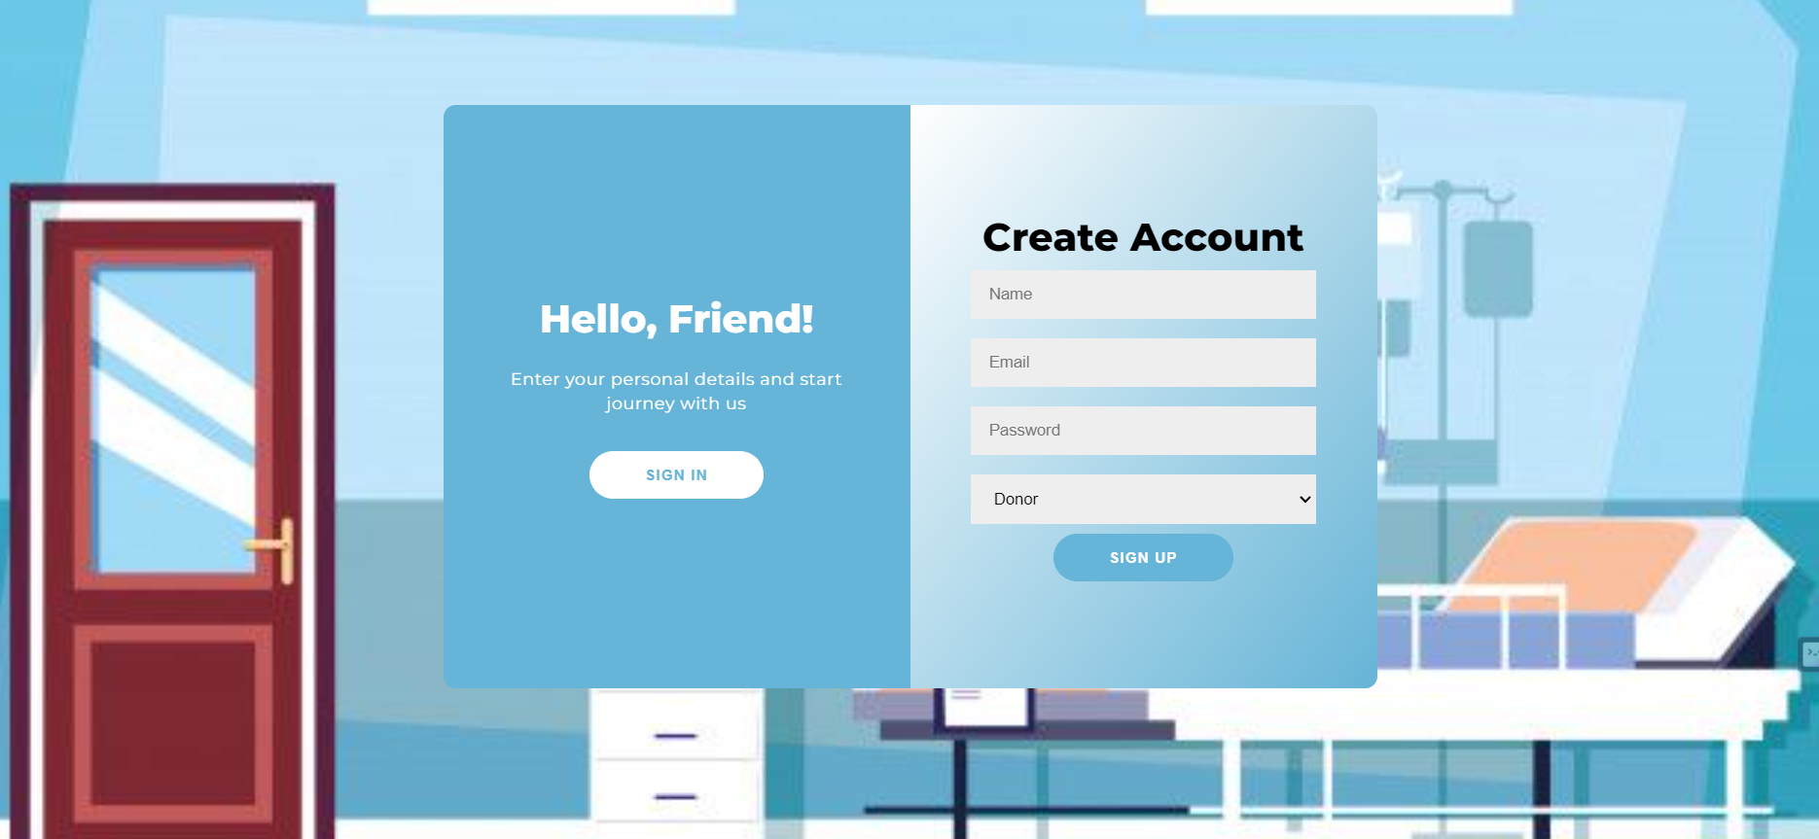

**4.4.3 Donor Login Page**

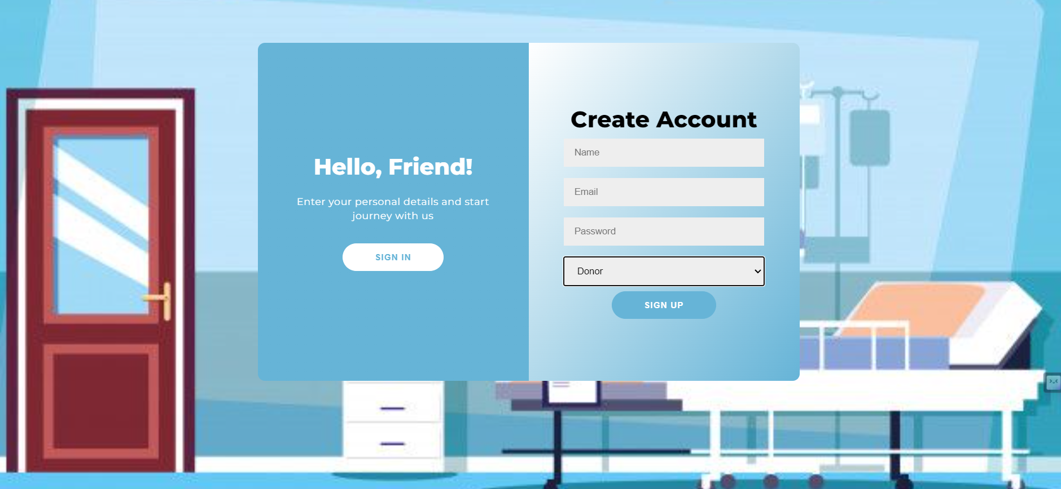

**4.4.4 Receiver Login Page**

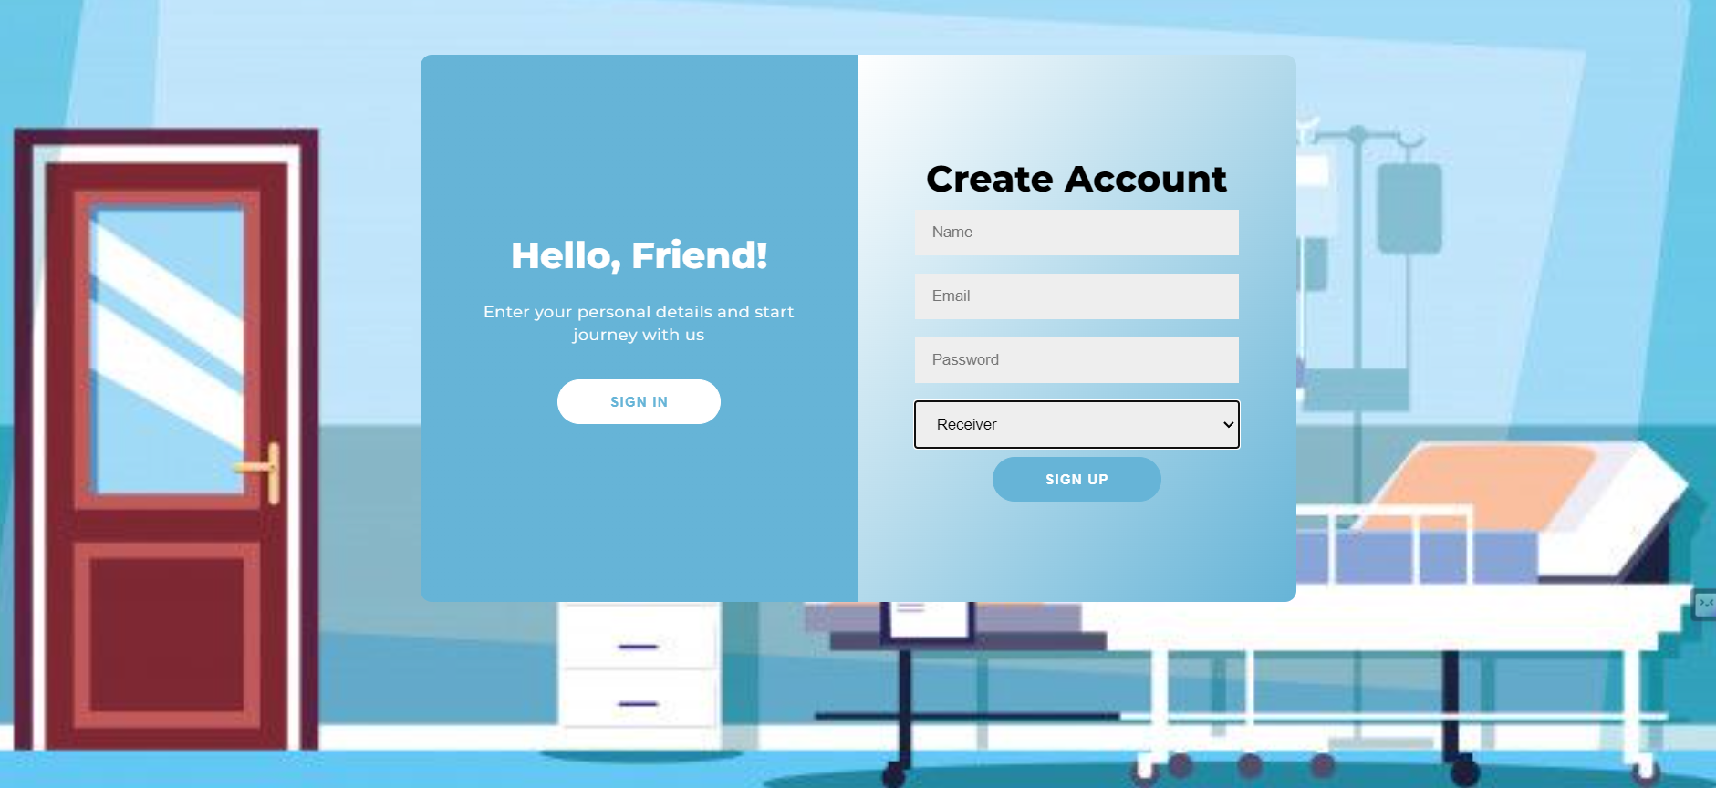

**Chapter 5**

**Technologies Used**

* **Hardware requirements:**

**Equipment** **:** PC, Laptop

**Numeric coprocessor :** Intel i5 and above

**RAM :** 4 GB

* **Software requirements:**

**OS :** Windows 11

**IDE :** VS Code

**Coding Language :** Javascript

**Database :** Mongodb

**Framework** :  **ExpressJS**

**Chapter 6**

**Results and Discussions**

**Results:**

1.User Adoption and Engagement: Describe the number of users who have registered on the online organ donation platform. Include statistics on the demographic characteristics of the users, such as age, gender, and location.

2.Number of Organ Donors and Recipients: Provide data on the number of individuals who have signed up as organ donors and the number of recipients who have found compatible donors through the platform.

3.Success Rates: Discuss the success rates of matching donors and recipients, including the time it takes for a successful match to occur and the factors that influence this process.

**Discussions:**

1.Impact on Organ Donation: Discuss how the online organ donation system has impacted the overall rate of organ donation in the region or community where it is implemented. Have there been noticeable increases in the number of organ donors and recipients?

2.Accessibility and Inclusivity: Explore whether the online system has made organ donation more accessible to a wider audience, including those from underserved communities, and whether there are any barriers that need to be addressed.

3.Challenges and Limitations: Identify any challenges or limitations of the system, such as the need for robust user education, concerns about data security, or the potential for a digital divide affecting access**.**

**Chapter 7**

**Conclusion and Future work**

**Conclusion:** This Application will provide better services to the people by connecting the Donor, Receiver as well as the Hospital in one platform. Through this application the Receiver will be able to find Donor as per its requirement, and the hospital will take a record of it. This System provided proper security to the data and from the Fake data record. The purpose of this application for organ donation and transplantation utilizing blockchain which is highly secure, transparent and cost effective. In this application a donor registers itself and gets approved by the hospital module Based on the request, the hospital module registers the recipient and matches with an appropriate donor.

**Future Work:**

In future we can develop this system to be more user friendly and add more organs that can be donated so that it can be easier for the receiver to get any organ which they want. There are people who still need other than organs like blood and plasma so we will try to make it such that the users will not only be able to receive organ but also blood plasma and other useful parts which is necessary for them.

**References**

1. Diana Hawashin, Raja jayaraman, Khaled Salah, Ibrar Yaqoob, Samer ellahham, “Blockchain-Based for Organ Donation and Transplantation”, 31st May 2022.

2. Pratyush Ranjan, Shubhanker Srivastava, Vidit Gupta, Shashikala Tapaswi, Neetesh Kumar, “Decentralised and Distributed system for organ tissue donation transplantation”, 2019.

3. Ms. Benita Jose Chalissery, Ms. Asha V, “An Intelligent Organ Distribution

using Internet of Things-Driven Systems”, 2019.

4. P.L Wijayathilaka, P.H Pahala Gamage, K.H.B De Silva, A.P.P.S Athukorala, K.A.D.C.P Kahandawaarachchi, K.N. Pulasinghe, “Blood and Organ Donation Management System”,2017.

5. Bhagya Lakshmi. D.N, Usha.S, “Tracking of Blood Donor and organ Donor Application”, ISSN:2277-3878, Volume-7, Issue-6S5, April 2019.

6. IDG Contributor Network. “How IoT helps transplant Surgeons Track Organ Shipments,” Internet: https://www.networkworld.com/article/3098879/internet-of-things/howiot-helps transplant-surgeons-track-organ-shipments.html. JUL 25, 2016. [Jul 12, 2017]

7.PatientSurvival.Available: http://www.gao.gov/special.pubs/organ/chapter6.pdf

8.Indian Society Of Organ Transplantation (ISOT):” ISOT newsletter,” Issue No. 2 May – August, 2015.[Online].Available : http://isot.co.i

**Acknowledgement**

We would like to express our sincere gratitude to our inspiring guide **Dr.Nilesh Deotale** who has extended all valuable guidance giving constant encouragement through various difficult stages of the development of the project. We express our sincere gratitude to our project Co-ordinator **Dr.Pratik Gite** for the encouragement and facilities provided to us. We would also like to acknowledge the patience that our ever-beloved parents have shown during our efforts and the encouragement we have received from them. Thus, we have fully obliged and convey our thanks to the teaching and as well as non-teaching staff of the Department of Computer Engineering. We would also like to thank **Dr.G.V.Mulgund (**Principalof St. John College of Engineering and Management) and the members of Adel Education Trust who has given us the background to conduct this T.E. Mini Project 2A.

Vrushal Patil [EU1212085]

Priyank Raut [EU1212120]

Chirag Rawat [EU1212029]

Ranu Singh [EU1212106]

**Bachelor of Computer Engineering**

**Third Year, Semester V**

**Session 2023**